STRIKE OUT CANCER! BOWLING DAY  For the  Montreal Children’s Hospital  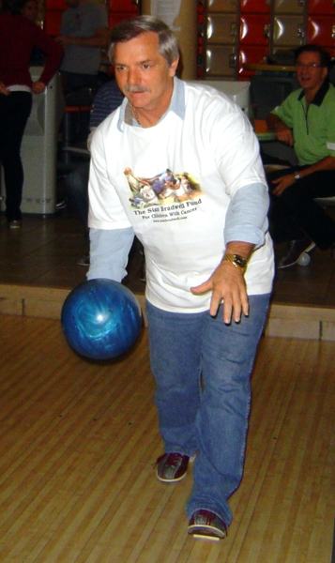  January 25th, 2020  The StrikeOut Cancer! Bowling Day is a fundraiser for the Haematology-Oncology Department of the Montreal Children’s Hospital. All proceeds go towards purchasing priority medical equipment for treating children with cancer.  Families that play together, stay together. The same is true for companies; boost your employee engagement while having fun for a great cause!  Organisations with high employee engagement outperform those with low employee engagement by 202%. Source:  https://risepeople.com/blog/employee-engagement-statistics/  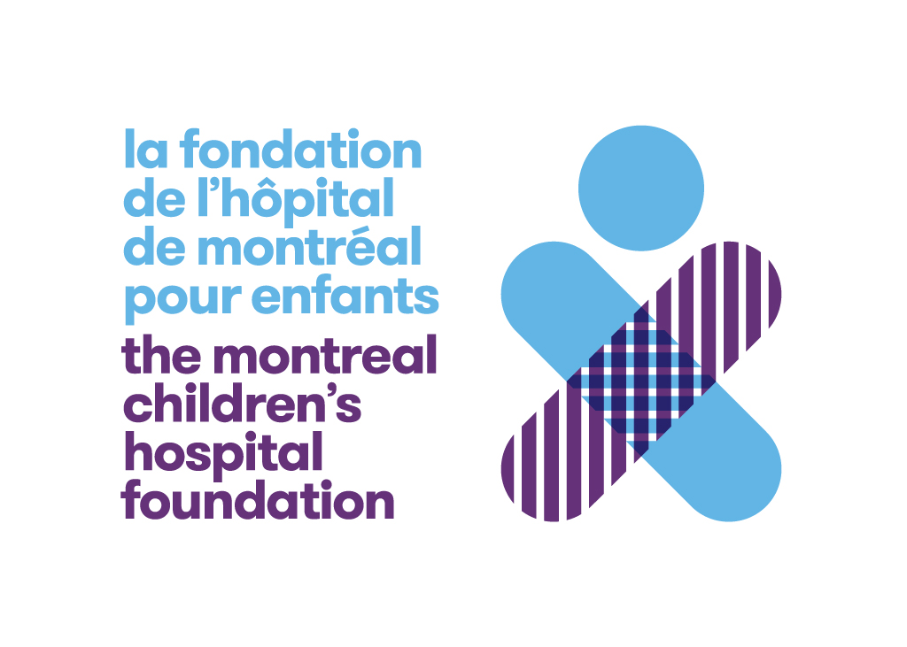  Montreal Children’s Hospital Foundation:  Alessia Di Giorgio  adig@mchf.com  514-934-4846 ext. 29237  3400 boul de Maisonneuve o.  1 Pl. Alexis Nihon, Suite 1420  Montreal, QC H3Z 3B8 | FEATURES  - Registration fee for 6 bowlers included  - 2 games, shoe rental plus all taxes included  - Team photos  - Your logo/advertisement on the monitors above each lane, plus receipt for advertising  - Special appearance by Montreal Children’s Hospital mascot Caramel  - Prize draw  - Team Spirit prize for the top fundraising team. Use the manual donation form on the next page or contact us to create your team fundraising page through the MCH secure web site.  FEE INFORMATION  N.B. Please ensure each of your players completes the Waiver and Release prior to the close of registration at 4 pm on January 24th.  https://www.eventbrite.ca/e/10th-strikeout-cancer-bowling-day-jan-25th-2020-waiver-and-release-tickets-74697270547?aff=ebdssbdestsearch  Teams may pay for their registration  - via a single payment of $350 via Interac e-transfer to bowling@sianbradwell.com (invoice -- stamped Paid -- for $200 advertising expenses provided)  - by cheque for $350  e-mail your completed registration form by January 20th to:  bowling@sianbradwell.com  or mail your registration form and cheque to:  The Sîan Bradwell Fund  c/o D.S. Bradwell (Asst. Treasurer)  1312 Rosseau Place  Burlington, ON L7P 3N2  Manual registration forms and cheques must be received by January 20^{th.} | REGISTRATION:  PLEASE USE BLOCK CAPITALS  Name of team: ________________________________  Company name:________________________________  Address: ________________________________  City: ________________________________  Prov, PostCode: ________________________________  Manager name: ________________________________  Work e-mail: ________________________________  Mobile Phone: ________________________________  Telephone: Day _______________________________  Web site: ________________________________  Payment by: e-transfer________ Cheque_________  Alternate contact:_______________________________  e-mail: ________________________________  Team members:  - _______________________________________  - _______________________________________  - _______________________________________  - _______________________________________  - _______________________________________  - _______________________________________  INFO: EVENT CO-ORDINATORS:  JULIE: 514-702-0101  jkarabetian@hotmail.com  LORIS: 438-505-1157  loris_sabini@hotmail.com  www.sianbradwell.com  www.sianbradwell.com
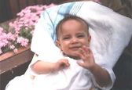The Sîan Bradwell Fund / Le Fonds Sîan Bradwell
DONORS / DONATEURS / DONATRICES

PLEASE USE BLOCK CAPITALS / S.V.P. ECRIRE EN LETTRES MOULEES
NAME / NOM |  | ADDRESS / ADRESSE | CITY / VILLE | PROV | POSTAL CODE /  CODE POSTALE | AMOUNT / MONTANT
1. |  |  |  | QC
2. |  |  |  | QC
3. |  |  |  | QC
4. |  |  |  | QC
5. |  |  |  | QC
6. |  |  |  | QC
7. |  |  |  | QC
8. |  |  |  | QC
9. |  |  |  | QC
10. |  |  |  | QC
11. |  |  |  | QC
12. |  |  |  | QC
13. |  |  |  | QC
14. |  |  |  | QC
15. |  |  |  | QC
16. |  |  |  | QC
17. |  |  |  | QC
18. |  |  |  | QC
For children with cancer / Pour les enfants atteints du cancer

Montreal Children's Hospital / Hôpital de Montréal Pour Enfants

TEAM NAME: _______________________________________________________________________________
tax receipts will be issued automatically for donations of $20 (due to administration costs) or more.  please make cheques payable to: the sîan bradwell fund - m.c.h.  Thank you so much . . . your donations are very important to us, and are deeply appreciated! |  | des reçus d'impots seront émis automatiquement pour les dons de 20$ et plus.  svp émettre vos cheques à l'ordre de: le fonds sîan bradwell - h.m.e.  Merci beaucoup . . . vos dons sont très importants pour nous, et sont grandement appréciés!

