STRIKEOUT CANCER BOWLING DAY  For the  Montreal Children’s Hospital  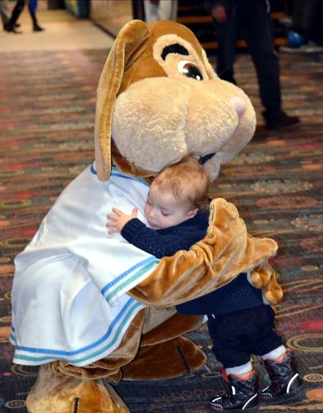  January 25th, 2020  The Strikeout Cancer Bowling Day is a day of fun for the whole family (or sports team or work team) while raising funds for the Montreal Children’s Hospital.  All proceeds go towards purchasing priority medical equipment. Most of the time, the equipment is for treating children with cancer, but sometimes there is an urgent need for medical equipment for other children.  For example, one of the items purchased through the Sian Bradwell Fund in 2019 was hardware and software to connect the ROTEM equipment in the Operating Room to the clinical labs in the Research Institute. This allows medical staff to obtain blood information immediately and ensure that the right blood product is given to the patient as soon as possible.  www.sianbradwell.com | FEATURES  - 2 games (takes about 2 hours), shoe rental plus all taxes included  - Team photos  - Special appearance by Montreal Children’s Hospital mascot Caramel  - Prize draw  - Social after the event (for your account)  GAMES AND FEE INFORMATION  N.B. Please ensure each of your players completes the Waiver and Release prior to the close of registration at 4 pm on January 24th.  https://www.eventbrite.ca/e/10th-strikeout-cancer-bowling-day-jan-25th-2020-waiver-and-release-tickets-74697270547?aff=ebdssbdestsearch  Teams may pay for their registration  - via a single payment of $120 via Interac e-transfer to bowling@sianbradwell.com  - by cheque for $120  The fee for Individuals is $20 per person.  e-mail your completed registration form by January 20th to:  bowling@sianbradwell.com  or mail your registration form and cheque (payable to The Sian Bradwell Fund) to:  The Sian Bradwell Fund  c/o J. Karabetian  24A Lakeshore Road  Beaconsfield, QC, H9W 4H3  Manual registration forms and cheques must be received by January 20^{th.} | REGISTRATION:  PLEASE USE BLOCK CAPITALS  Name of team: : ________________________________  Manager name: ________________________________  Address: ________________________________  City: ________________________________  Prov., PostCode: ________________________________  Work e-mail: ________________________________  Mobile Phone: ________________________________  Telephone: Day ________________________________  Web site : ________________________________  Alternate contact: ________________________________  Mobile Phone: ________________________________  e-mail: ________________________________  Team members: (max. 6 bowlers per lane)  - _______________________________________  - _______________________________________  - _______________________________________  - _______________________________________  - _______________________________________  - _______________________________________  INFO: EVENT CO-ORDINATORS:  JULIE: 514-702-0101  jkarabetian@hotmail.com  LORIS: 438-505-1157  loris_sabini@hotmail.com  www.sianbradwell.com

