Sîan Bradwell  Softball Tournament  For the  Montreal Children’s Hospital  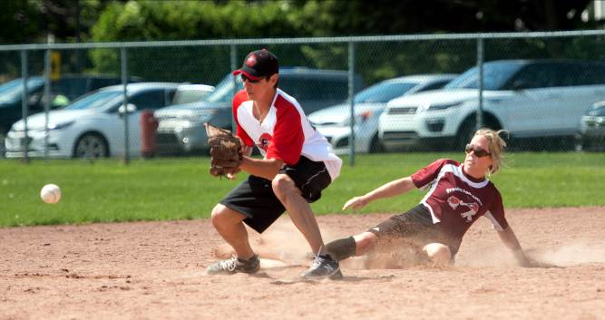  July 28th – 31st, 2022  The Sîan Bradwell Softball Tournament [SBST] is run by entirely by volunteers to raise funds for priority medical equipment required by the Haematology-Oncology Department of the Montreal Children’s Hospital.  www.sianbradwell.com  FEATURES  - Sections: 3:- Mixed (Co-ed), Men’s A and B  - Each team is scheduled to play a minimum of 3 games, weather permitting.  - Team photos are distributed through the annual book, which is posted on the SBF web site.  - Awards are given to individuals on teams which reach the finals.  - If maximum capacity is reached, teams which have participated the previous year receive preference for playing  - Delicious sausages, hamburgers, hot dogs, beer and soft drinks are available on site for moderate prices. Please support our efforts on behalf of the children! | GAMES AND FEE INFORMATION  With electronic payments bring available through financial institutions without fees, the organisers of the “SBST” are no longer accepting registration fees via cash or cheque, to make it easier for our volunteers. If your team requires special consideration, contact us: contact@sianbradwell.com  Teams may pay their registration in several ways:  - by a single payment of $450 via credit card (receives an income tax receipt).  - by collecting a minimum of $450 in donations, the registration fee will be waived. Donations by players, friends, work colleagues or any other supporters can be collected online: send your team name to sbst@sianbradwell.com and we will create your fundraising page on the Mtl. Children’s Hospital secure web site. All online donations RECEIVE TAX receipTS, regardless of amount. Tax receipts for manual donations of $20+.  - by Interac e-transfer for $350 (not receipted) sbst@sianbradwell.com  Send your completed form and e-transfer by June 29th to:  sbst@sianbradwell.com  *** Please ensure all your players sign the Player Waiver and Release form BEFORE THE CUT-OFF AT 4 P.M. ON JULY 28th. ***  RULES WAIVERS MAPS | TEAM REGISTRATION:  PLEASE USE BLOCK CAPITALS  Name of team: : ________________________________  Division:: ________________________________  Shirt colour: ________________________________  Manager name: ________________________________  Mobile Phone: ________________________________  Telephone: Day ________________________________  Evenings: : ________________________________  Work e-mail: ________________________________  Home e-mail: ________________________________  Address: ________________________________  City: ________________________________  Prov., PostCode: ________________________________  Fees paid by: ____ Online donations ____ e-transfer  Alternate contact: ________________________________  Mobile Phone: ________________________________  e-mail: ________________________________  Nights on which your league plays: _______________________________________________  _______________________________________________  _______________________________________________  Schedule consideration requests:  _______________________________________________  _______________________________________________  _______________________________________________  Please remember that with limited park time, we may not be able to accommodate all requests.  AS A RULE, SCHEDULE CHANGES WILL NOT BE MADE AFTER THE SCHEDULE HAS BEEN DRAWN.  MIXED: Gary Kukulsky 514-262-2527  Domenic Cimino 438-402-9610  MEN’S A: Steve Bouchard 514-795-4230  Sam Rother 514-898-9499  MEN’S B: Neil Semenchuk 514-726-0831  Mario Papadopoli 514-426-4150  www.sianbradwell.com
TEAM ROSTER

 | FIRST NAME | LAST NAME
1.
2.
3.
4.
5.
6.
7.
8.
9.
10.
11.
12.
13.
14.
15.
16.
17.
18.

