Sîan Bradwell  Softball Tournament  For the  Montreal Children’s Hospital  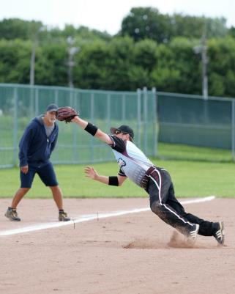  August 3rd – 6th, 2023  The Sîan Bradwell Softball Tournament [SBST] is run by entirely by volunteers to raise funds for priority medical equipment required by the Haematology-Oncology Department of the Montreal Children’s Hospital. Please support our efforts on behalf of the children!  How funds are used:  - Letter from Dr. Thomas Engelhardt (2022)  - Note from Dr. Chantal Bernard (2021) | FEATURES  - Games officiated by umpires certified by Softball Québec.  - Each team is scheduled to play a minimum of 3 games, weather permitting. Pitcher’s protective net for safety.  - Pitch must have a perceptible arc. No windmill or Figure 8 pitches.  - Team photos are distributed through the annual book, which is posted on the SBF web site.  - Delicious sausages, hamburgers, hot dogs, beer and soft drinks are available on site for moderate prices.  GAMES AND FEE INFORMATION  Teams may pay their registration in three ways:  - by Interac e-transfer for $450 to sbst@sianbradwell.com  - by cheque for $450 – delivered or mailed to:  Sian Bradwell Softball Tournament  97 Rue Daudelin  Kirkland, QC H9J 2J4  - in cash – delivered to the address above.  Send registration form to: sbst@sianbradwell.com  NOTE: Fees MUST be received by July 1st, otherwise the team will not be considered as having registered.  *** Please ensure all your players sign the Player Waiver and Release form BEFORE THE CUT-OFF AT 4 P.M. ON AUGUST 1st. ***  RULES WAIVERS MAPS  LIST OF NON-APPROVED BATS | TEAM REGISTRATION:  PLEASE USE BLOCK CAPITALS  Name of team: : ________________________________  Division:: ________________________________  Shirt colour: ________________________________  Manager name: ________________________________  Mobile Phone: ________________________________  Telephone: Day ________________________________  Evenings: : ________________________________  Work e-mail: ________________________________  Home e-mail: ________________________________  Address: ________________________________  City: ________________________________  Prov., PostCode: ________________________________  Fees paid by: ____ Online donations ____ e-transfer  Alternate contact: ________________________________  Mobile Phone: ________________________________  e-mail: ________________________________  Nights on which your league plays: _______________________________________________  _______________________________________________  _______________________________________________  AS A RULE, CHANGES WILL NOT BE MADE AFTER THE SCHEDULE HAS BEEN DRAWN.  Schedule consideration requests:  Please remember that with limited park time, we may not be able to accommodate all requests.  _______________________________________________  _______________________________________________  _______________________________________________  www.sianbradwell.com

