KEN BRADWELL SOCCER Tournament  TO BENEFIT  JOSEPH BRANT HOSPITAL  OAKVILLE TRAFALGAR MEMORIAL HOSPITAL  JURAVINSKI CANCER CENTRE  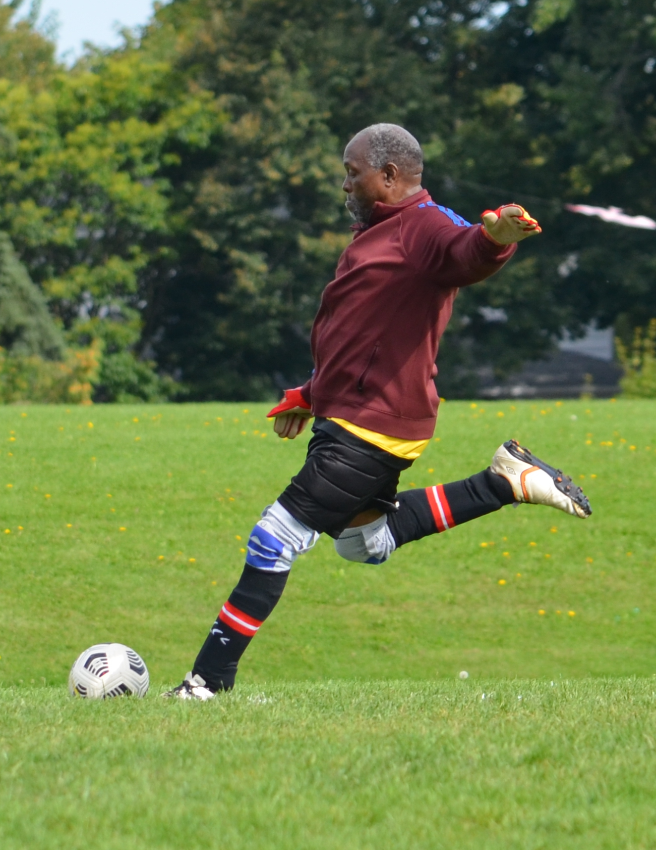  August 31st, 2024  When new healthcare facilities are built, governments contribute a portion of the cost of major items such as magnetic resonance imaging and CT scanners and other high-priced equipment. Smaller items and replacement equipment IS NOT FUNDED, so hospitals rely on fundraising and public donations to provide for these expenses.  Funds raised through the Ken Bradwell Soccer Tournament (KBST) – hosted jointly by the Burlington Soccer Club and Burlington OldTimers Soccer Club – are used to purchase priority medical equipment at the Oakville Trafalgar Memorial Hospital, Joseph Brant Hospital, and Juravinski Cancer Centre, which is the regional cancer centre.  Your generous support in 2023 through the KBST and personal donations helped us raise $14,597.85 for the hospitals, and is deeply appreciated. Income tax receipts are issued for ALL online donations. | GAMES AND FEE INFORMATION  - Venue: Brant Hills Community Centre (2300 Duncaster Drive, Burlington, Ontario)  - Men’s 40+, Men’s 50+ and Men’s 60+ teams play a minimum of 3 games, weather permitting.  - Team photos are distributed to all teams after the tournament and appear in the souvenir programme the following year.  - Participation is on a first-come, first-served basis. If maximum capacity is reached, teams are placed on a waiting list.  - The team registration fee of $600 includes lunch.  - Kennypalooza! social follows the tournament.  TEAM REGISTRATION  The deadline for submitting this registration form is August 15th.  * Teams may submit a deposit of $200 by July 15th to reserve their places. A team is not considered “registered” until a deposit has been received. The balance of $400 is due by August 15th.  * Registration fees and deposits may be sent via e-transfer to: kb-acct@sianbradwell.com  Further info: http://sianbradwell.com/football-kbst/  Questions? kbst@sianbradwell.com  PLAYER REGISTRATION AND WAIVER  Deadline: 11 p.m. on August 30th  Player Registration and Waiver Form | TEAM REGISTRATION DETAILS:  PLEASE USE BLOCK CAPITALS  Name of team: ________________________________  Division: ________________________________  Shirt colour: ________________________________  Manager name: ________________________________  Mobile Phone: ________________________________  Telephone: Day: ________________________________  Evenings: ________________________________  e-mail (home): ________________________________  e-mail (work): ________________________________  Address: ________________________________  City: ________________________________  Prov., PostCode: ________________________________  Alternate contact: ________________________________  Mobile Phone: ________________________________  Evenings: ________________________________  e-mail address: ________________________________  All participants are required to sign the Player Registration and Waiver Form. Please ensure all players have registered online by the deadline.  Online Donations:  Joseph Brant: Ken Bradwell Foundation  Oakville Trafalgar: Ken Bradwell Foundation  Juravinski Cancer: Ken Bradwell Foundation  