Sîan Bradwell  34th  Softball Tournament  For the  Montreal Children’s Hospital  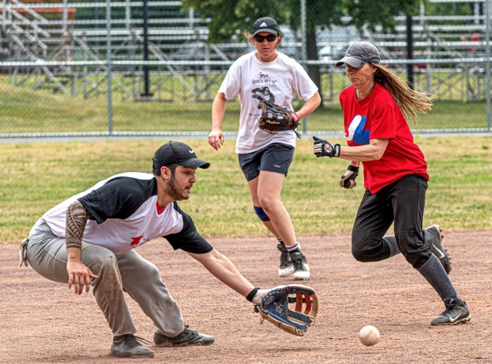  August 1st – 4th, 2024  The Sîan Bradwell Softball Tournament [SBST] is held to raise funds for priority medical equipment required by the Haematology-Oncology Department of the Montreal Children’s Hospital.  FEATURES  - Each team is scheduled to play a minimum of 3 games, weather permitting. May include a Thursday or Friday night game. Playoffs are on Sunday, not all teams necessarily qualify.  - Team photos are distributed through the annual book, which is posted on the SBF web site.  - Awards are given to individuals on the winning team for each division.  - Participation is on a first-come, first-served basis. If maximum capacity is reached, teams are placed on a waitlist.  - Delicious sausages, hamburgers, hot dogs, beer and soft drinks are available on site for moderate prices. Please support our efforts on behalf of the children! | GAMES AND FEE INFORMATION  Teams may pay their registration in several ways:  - by a single payment of $450 via credit card (receives an income tax receipt).  - by collecting a minimum of $450 in donations, the registration fee will be waived. Donations by players, friends, work colleagues or any other supporters can be collected online: send your team name to sbst@sianbradwell.com and we will create your fundraising page on the Mtl. Children’s Hospital secure web site. All online donations RECEIVE TAX receipTS, regardless of amount. Tax receipts for manual donations of $20+.  - by Interac e-transfer for $350 to: sbst@sianbradwell.com (no tax receipt)  - by cheque for $350 (no tax receipt). Must be mailed to: 97 Rue Daudelin, Kirkland H9J 2J4  PLEASE NOTE THAT WE NO LONGER ACCEPT CASH.  Payment and registration form must be received by July 1st, otherwise the team will not be considered as officially registered. Don’t risk losing your place and miss out on the fun!  Send your completed form and e-transfer by July 1st to:  sbst@sianbradwell.com  *** Please ensure all your players sign the Player Waiver and Release form BEFORE THE CUT-OFF AT 4 P.M. ON JULY 29th. ***  RULES WAIVERS MAPS  LIST OF NON-APPROVED BATS | TEAM REGISTRATION:  PLEASE USE BLOCK CAPITALS  Name of team: : ________________________________  Division:: Mixed A ________ Mixed B ________  Shirt colour: ________________________________  Manager name: ________________________________  Mobile Phone: ________________________________  Telephone: Day ________________________________  Evenings: : ________________________________  Work e-mail: ________________________________  Home e-mail: ________________________________  Address: ________________________________  City: ________________________________  Prov., PostCode: ________________________________  Fees paid by: Donation____e-transfer___CrCd._____  Alternate contact: ________________________________  Mobile Phone: ________________________________  e-mail: ________________________________  Restrictions:  Please remember that with limited park time, we may not be able to accommodate all requests.  _______________________________________________  _______________________________________________  AS A RULE, CHANGES WILL NOT BE MADE AFTER THE SCHEDULE HAS BEEN DRAWN.  DIVISION CO-ORDINATORS TELEPHONE  PEPSI: Gary Kukulsky 514-262-2527  MIXED: Lisa-Marie Gingera 514-898-7969  Lindsey Dalley 514-883-2438  Kelly Corsi 514-898-7745  Gayle Berry  MEN’S: Sharon Bradwell 514-500-3300  KMSPL: Steve Bouchard 514-795-4230  www.sianbradwell.com

