  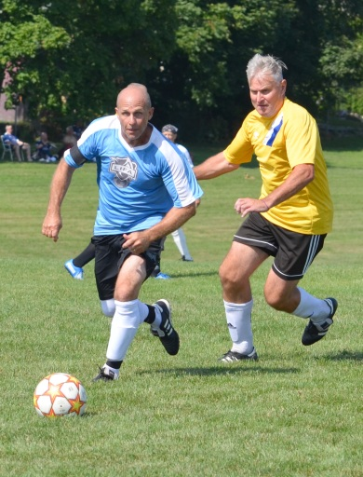  September 5th, 2026  When new healthcare facilities are built, governments contribute a portion of the cost of major items such as magnetic resonance imaging and CT scanners and other high-priced equipment. Smaller items and replacement equipment are not funded, so hospitals rely on fundraising and public donations to provide for these expenses.  Funds raised through the Ken Bradwell Soccer Tournament (KBST) – hosted jointly by the Burlington Soccer Club and Burlington OldTimers Soccer Club – are used to purchase priority medical equipment at the Oakville Trafalgar Memorial Hospital, Joseph Brant Hospital, and Juravinski Cancer Centre, which is the regional cancer centre for Halton, Hamilton and the surrounding area.    Income tax receipts are issued for ALL online donations. | GAMES AND FEE INFORMATION  - Venue: Brant Hills Community Centre (2300 Duncaster Drive, Burlington, Ontario)  - Men’s 40+, Men’s 55+, Walking soccer  - Teams play a minimum of 3 games, weather permitting.  - Team photos appear in the souvenir book: https://sianbradwell.com/annual-book/annual-books/  - Participation is on a first-come, first-served basis. If maximum capacity is reached, teams are placed on a waiting list.  - The team registration fee of $700 includes lunch.  - Kennypalooza! social follows the tournament.  TEAM REGISTRATION  The deadline for submitting this registration form is August 22nd.  - Teams may submit a deposit of $200 by July 15th to reserve their places. A team is not considered “registered” until a deposit has been received.  - The balance of $500 is due by August 22nd.  - Registration forms and payments may be sent via e-transfer to:  kb-acct@sianbradwell.com  Further info: http://sianbradwell.com/football-kbst/  Questions? kbst_info@sianbradwell.com  PLAYER REGISTRATION AND WAIVER  Must be signed by all players  Deadline: 8 p.m. on September 4th  Player Registration and Waiver Form | TEAM REGISTRATION DETAILS:  PLEASE USE BLOCK CAPITALS  Name of team: ________________________________  Division: ________________________________  Shirt colour: ________________________________  Manager name: ________________________________  Mobile Phone: ________________________________  Telephone: Day: ________________________________  Evenings: ________________________________  e-mail (home): ________________________________  e-mail (work): ________________________________  Address: ________________________________  City: ________________________________  Prov., PostCode: ________________________________  Alternate contact: ________________________________  Mobile Phone: ________________________________  Evenings: ________________________________  e-mail address: ________________________________  ALL PARTICIPANTS are required to sign the Player Registration and Waiver Form. Please ensure your players have registered online by the deadline.  N.B.  Please remember that primary the aim of this tournament is to raise funds for charity.  We ask all participating teams be respectful of officials, other players and volunteers, and to keep in mind that this tournament is being held for the benefit of our community. All of us are here just to have fun.
  Les Bell | Tournament Director
  Brian McLaughlin | Tournament Director
  Brendon O’Brien | Treasurer
  Andy Murty | Umpire-in-Chief

