Sîan Bradwell  36th  Softball Tournament  For the  Montreal Children’s Hospital  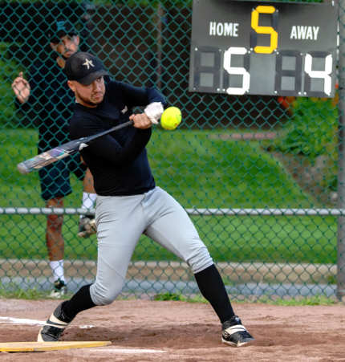  August 6th – 9th, 2026  The Sîan Bradwell Softball Tournament [SBST] is a fundraiser for priority medical equipment required by the Haematology-Oncology Department of the Montreal Children’s Hospital.  Current project: 40 intravenous infusion pumps at a cost of $5,000 each. We are over half-way there!  At times, one child with cancer may need up to 3 pumps at a time (chemotherapy drugs, pain medication, hydration).  Please help us provide the best medical care possible for children who are fighting for their very lives. Thank you.         | FEATURES  - Games officiated by umpires certified by Softball Québec.  - Each team is scheduled to play a minimum of 3 games, weather permitting.  - Team photos are distributed through the annual book, which is posted in the SBF photo gallery.  - Food and beverages are available on site.  Please help us raise funds for the Children’s and refrain from bringing your own.  GAMES AND FEE INFORMATION  Teams will qualify for an earlybird discount if registration fees are received BY JULY 1st:  - by Interac e-transfer for $550 to sbst@sianbradwell.com  - by donation – minimum $650 in donations collected on the Montreal Children’s Hospital secure web site. All ONLINE donations receive a tax receipt, regardless of amount.  Teams must raise at least $550 by July 1st.  AFTER JULY 1st: registration fee is $600  Send registration and e-transfer to: sbst@sianbradwell.com  RULES WAIVERS MAPS  LIST OF NON-APPROVED BATS  Questions? Andy Brookman: 514-967-6281 | MEN’S DIVISION TEAM REGISTRATION:  PLEASE USE BLOCK CAPITALS  Name of team: : ________________________________  Estimated Strength 1 to 10 (1-weak 10-strong): _______  Division:: ________________________________  Shirt colour: ________________________________  Manager name: ________________________________  Mobile Phone: ________________________________  Telephone: Day ________________________________  Evenings: : ________________________________  Work e-mail: ________________________________  Home e-mail: ________________________________  Address: ________________________________  City: ________________________________  Prov., PostCode: ________________________________  Fees paid by: Donation ___e-transfer ____ Chq.____  Alternate contact: _______________________________  Mobile Phone: ________________________________  e-mail: ________________________________  *** BY ENTERING THIS TOURNAMENT, PLAYERS AND MANAGERS ACKNOWLEDGE THAT THEIR IMAGES MAY BE USED. ***  Schedule consideration requests:  While we will try to accommodate requests, there is no guarantee that we can do so.  _______________________________________________  _______________________________________________  _______________________________________________  AS A RULE, CHANGES WILL NOT BE MADE AFTER THE SCHEDULE HAS BEEN DRAWN.    www.sianbradwell.com

