Sîan Bradwell  36th  Softball Tournament  For the  Montreal Children’s Hospital  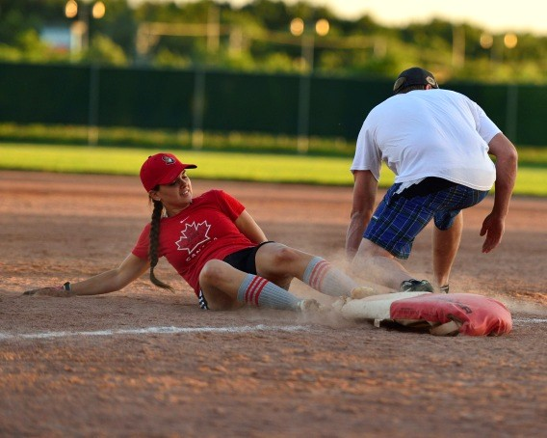  August 6th – 9th, 2026  The Sîan Bradwell Softball Tournament [SBST] is a fundraiser for priority medical equipment required by the Haematology-Oncology Department of the Montreal Children’s Hospital.  Current project: 40 intravenous infusion pumps at a cost of $5,000 each. We are over half-way there!  At times, one child with cancer may need up to 3 pumps at a time (chemotherapy drugs, pain medication, hydration).  Please support our efforts on behalf of the children!         | FEATURES  - Games officiated by appointed umpires.  - Each team is scheduled to play a minimum of 3 games, weather permitting. Pitcher’s protective net for safety. Skills competition.  - Participation is on a first-come, first-served basis. If maximum capacity is reached, teams are placed on a waiting list.  - Team photos are distributed through the annual book, which is posted in the SBF photo gallery.  - Food and beverages are available on site. Please help us raise funds for the Children’s and refrain from bringing your own.  GAMES AND FEE INFORMATION  Teams will qualify for an earlybird discount if registration fees are received BY JULY 1st:  - by Interac e-transfer for $450 to sbst@sianbradwell.com  - by donation – minimum $550 in donations collected on the Montreal Children’s Hospital secure web site. All ONLINE donations receive a tax receipt, regardless of amount.  Teams must raise at least $450 by July 1st.  AFTER JULY 1st: registration fee is $500  Send registration form to: sbst@sianbradwell.com  RULES WAIVERS MAPS  LIST OF NON-APPROVED BATS | MIXED DIVISION TEAM REGISTRATION:  PLEASE USE BLOCK CAPITALS  Name of team: : ________________________________  Estimated Strength 1 to 10 (1-weak 10-strong): _______  Shirt colour: ________________________________  Manager name: ________________________________  Mobile Phone: ________________________________  Telephone: Day ________________________________  Evenings: : ________________________________  Work e-mail: ________________________________  Home e-mail: ________________________________  Address: ________________________________  City: ________________________________  Prov., PostCode: ________________________________  Fees paid by: Donation______ e-transfer______  Alternate contact: ________________________________  Mobile Phone: ________________________________  e-mail: ________________________________  Schedule consideration requests:  While we will try to accommodate requests, there is no guarantee that we can do so.  _______________________________________________  _______________________________________________  _______________________________________________  AS A RULE, CHANGES WILL NOT BE MADE AFTER THE SCHEDULE HAS BEEN DRAWN.  *** BY ENTERING THIS TOURNAMENT, PLAYERS AND MANAGERS ACKNOWLEDGE THAT THEIR IMAGES MAY BE USED. ***
  DIVISION | CO-ORDINATORS | TELEPHONE
  PEPSI: | Dominic Nadeau ?
  MIXED: | Kelly Corsi | 514-898-7745
   | Lisa-Marie Gingera | 514-898-7969
   | Jason Pepper ? | 514-688-6182

