

43rd POINTE-CLAIRE

Softball Tournament

AUGUST 20th – 23rd, 2026

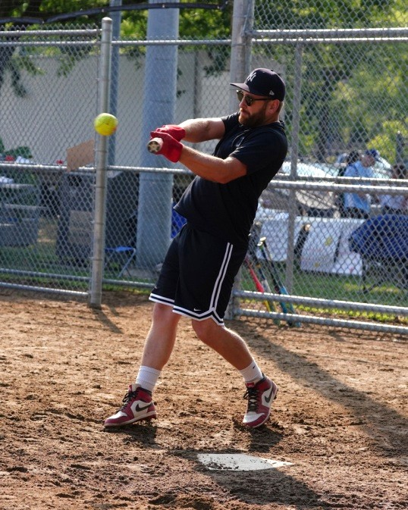
The Pointe-Claire Softball Tournament is run by volunteers and raises funds for high-priority medical equipment for the Lakeshore General Hospital through the Al & Millie De Souza Foundation.

Each team is scheduled to play a minimum of 3 games, weather permitting.

Registration fee: $500

Send your completed form and e-transfer by August 1st to: cphmsl01@gmail.com

Or mail your registration and cheque (must be received by August 1st) to:
Liam Alcalde (Tournament Director)
176 Belmont Avenue
Pointe-Claire, QC H9R 2P9

TEAM REGISTRATION:
PLEASE USE BLOCK CAPITALS

Name of team: ____________________________________________________________________
Division: Men’s Open_(D/E calibre) ______ Men’s Alumni (35 & Over) ______ Mixed _____
Shirt colour: ____________________________________________________________________
Manager name: ____________________________________________________________________
Mobile Phone: ____________________________________________________________________
Telephone: Day ____________________________________________________________________
Evenings: ____________________________________________________________________
Work e-mail: ____________________________________________________________________
Home e-mail: ____________________________________________________________________
Address: ____________________________________________________________________
City: ____________________________________________________________________
Province, Post.Code: ____________________________________________________________________
Alternate contact: ____________________________________________________________________
Mobile Phone: ____________________________________________________________________
e-mail: ____________________________________________________________________

